1. Pre-requisites for Full Closed Loop V 3.8
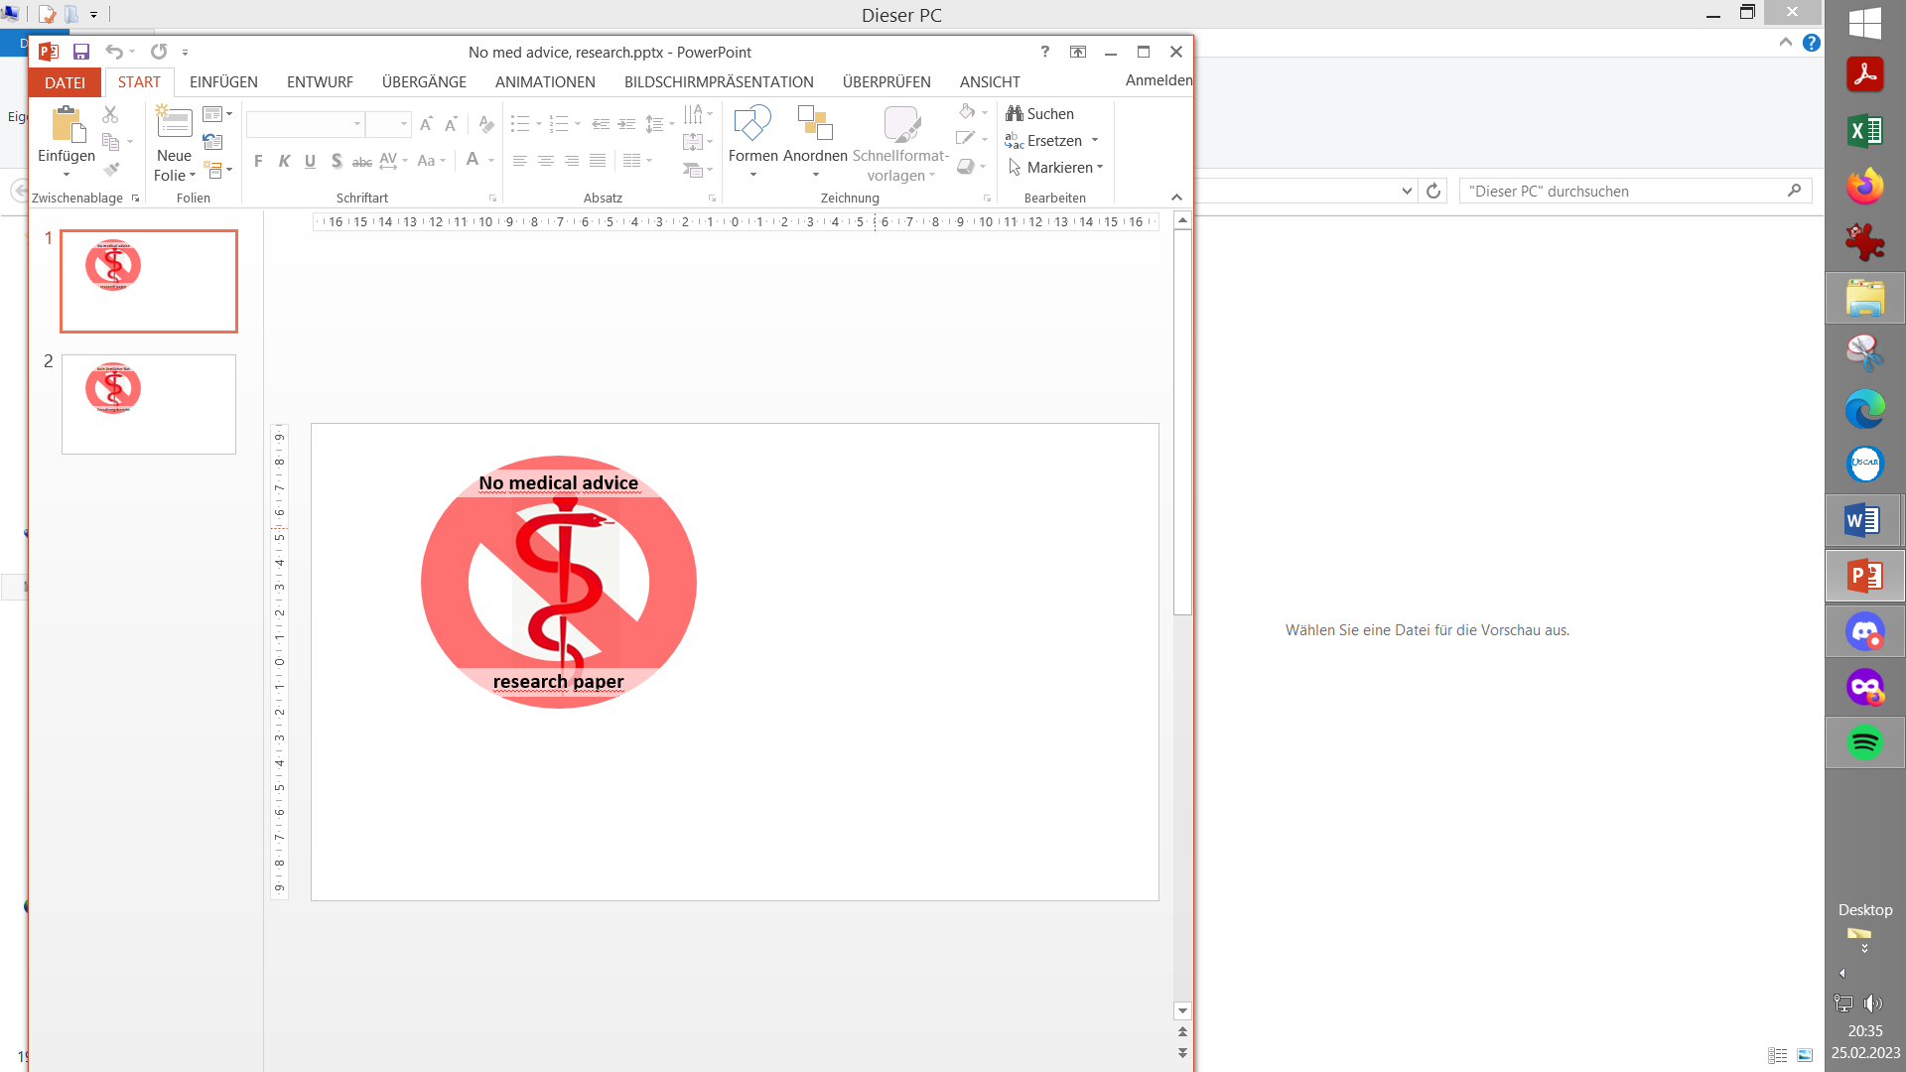
Please note that with autoISF you are in an early-dev. environment, where the user interface is not optimized for safety of users who stray away from intended ways to use. Good safety features exist, but these are only as good as the development-oriented user understands and implements them. This is not a medical product, refer to disclaimer in section 0

1.1 Well tuned hybrid closed loop
Available related case studies:
Case study 1.1: Occlusion
Case study 1.2: Comparing insulins for FCL
Case study 1.3: Jumpy CGM
Case study 1.4: Lost pump connection
Case study 1.5: Overlapping 2 CGMs
Case study 1.6: When catastrophy strikes
Case study 1.7: MDI when the loop dies
Case study 1.8: Libre3 (1 minute) placeholder
1.2 Fast insulin
1.3 Reliable insulin delivery from pump and cannula
1.4 Excellent CGM
1.5 Meal-related limitations?
1.6 Lifestyle-related limitations?
1.7 Time required for setting-up

1.1 Well-tuned hybrid closed loop (HCL)

It is advisable to first establish a well-tuned hybrid closed loop before considering the transition to FCL. Best if you achieved good HCL performance without using Autotune or dynamicISF (which can introduce, or cover up, problems that would get exposed in your transition to Full Closed Loop (FCL); more see at beginning of section 4).

There are three important reasons for starting on a solid basis (profile):
- The UAM full closed loop requires a highly personalized (individual) tuning of settings, so the loop will give insulin mimicking YOUR successful hybrid closed loop mode.
- Key autoISF tuning parameters multiply with your profile_ISF. You could be “big time starting on the wrong foot”, and potentially waste a lot of tuning time with your autoISF! See for example: red box in section 4.3.2
- The UAM full closed loop comes with new parameters to be set and tuned. It would be problematic to set and tune several new parameters before the basics were tuned “right”. Errors could easily be balanced with counter-errors. This can work in single scenarios, but would create a highly unstable system. It would be very hard to re-calibrate better later, too.

1.2 Fast insulin (Lyumjev, Fiasp, Apidra?)

It should be clear without saying, but it is absolutely necessary to feed your loop with correct time-to-peak and DIA for your insulin, so it has any chance to know how the iob will get active in your body. See “Insulin_DIA…pdf” in: https://github.com/bernie4375/HCL-Meal-Mgt.-ISF-and-IC-settings

If the user does not bolus for meals, clearly a very fast insulin is needed so, upon realization of a starting meal-related glucose rise, the loop has any chance to eventually keep glucose in range (by common definition, under 180 mg/dl (10 mmol/l))

A modelling study..
key findings are summarized in initial section of case study 1.2; for more see: “The artificial pancreas and meal control…pdf” in: https://github.com/bernie4375/HCL-Meal-Mgt.-ISF-and-IC-settings/blob/HCL-.-settings-main-repo-(pdf)/
…can show in quantitative terms, that faster insulins:
- will result in significantly lower glucose peaks than slower insulins
- tolerate a couple of minutes delayed first meal bolus while not incurring unacceptable height of peaks
- minimize the effect on glucose peak from different carb load (meal sizes).
In conclusion, do not attempt FCL with other insulin than Lyumjev® or Fiasp®.
Potential exceptions:
  - Being consistently on low carb, on a GLP-1 drug, or with gastroparesis -all of which ease the job of a FCL significantly.
  - According to case study 1.2, Apidra® might work, too, but Humalog® would not work well (with “normal diet”).

1.3 Reliable insulin delivery from the used pump/cannula/insulin system

Good tolerance of Lyumjev (or Fiasp): Occlusions threaten the function of the full closed loop.

It is very important to have an eye on the time a cannula (or pod) is in use (many find 48 hrs to be the limit), and whether hard-to-explain glucose rises happen at ever increasing „fake“ iob (even before a 48 hr routine replacement). (You easily lose 25% TIR that day, see case study 1.1)
It is absolutely contra-indicated to attempt FCL coming from leaking pods and associated erratic sensitivity swings that may or may not have been somewhat controlled and tolerable by dynamicISF or other measures when you were Hybrid Closed Looping,
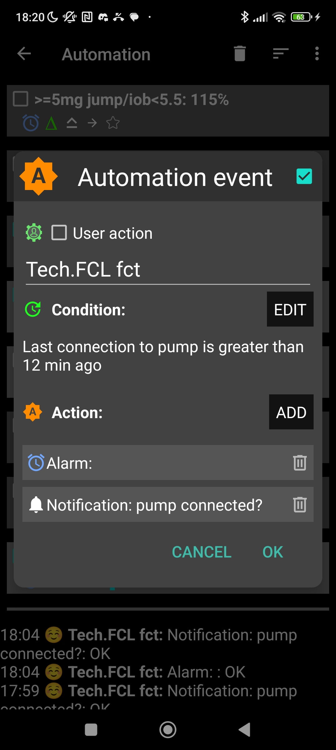
Stable pump connection (see case studies 1.4 and 1.6)
In FCL you absolutely rely on your pump delivering, without any further delay, the much needed insulin, after any meal start.
Hence it is absolutely essential to avoid any problems from a lost Bluetooth connection. In AAPS preferences / Local alerts, switch alert on! An Automation similar to the one pictured here → could also help recognizing eventual problems.

See also case study 1.4

1.4 Excellent CGM

You do not give a meal size-related bolus any longer. That leaves all insulination jobs to the algorithm! Around meals, a stable Bluetooth connectivity is absolutely essential, too, so CGM, loop, and pump can do their job without losing more valuable time (see case study 1.4).

As glucose values are the very basis for your autoISF loop, please inform yourself well about your CGM:

- How it principally performs (e.g. you absolutely must be “SMB always-ready” at cob=0)
- Whether you are using the best suited intermediate app that reports the “raw” value from the CGM transmitter into AAPS
- Specifically, how and where any smoothing is done, and what this might imply for the ISF boosting method you will be using See for instance here: https://androidaps.readthedocs.io/en/latest/Usage/Smoothing-Blood-Glucose-Data.html
- Go through your data (in all day and also night times) to see whether your CGM produces any artefacts (jumpy values; see case study 1.3) that the loop could misinterpret as sign of a starting meal.
For some of these problems, e.g. “jumps” associated with nighttime compression lows, there are options to mitigate (see section 5.1.2./3.) . See also the User Action Automation discussed about 2 pages below (line 149ff).
- In case your CGM requires calibrations: Note that calibrations often produce jumps. In that case, be prepared to do, in the future, an extra handling step to protect from your FCL reacting harshly.

autoISF has also a couple of in-built checks on the quality of the recent CGM values.

They are particularly important in the acceleration detection.
You will learn more about how a “lousy” CGM performance can badly interfere with your tuning, and resulting autoISF loop performance, in section 4.2.4 (see red warning box there).

To summarize, a CGM with more scatter will make the loop lose more time, and lead to higher peaks and lower %TIR.

So, if you are unhappy with a slow reaction of your loop it could be because the loop is unhappy with your CGM.
Consult the detail info given (at the time) in your AUTO ISF tab, or look it up later in the logfiles (using the Emulator, section 10, eventually).

Note that, as a FCL user, you must put an elevated emphasis on avoiding jumpy values that could be mistaken by your FCL as start of a meal.

1.4.1 Dexcom G6 and other 5-minute CGMs

The best proven way to stay out of trouble currently is to use Dexcom G6, and to ensure via overlapping right and left arm sensor and transmitter utilization always good quality values, that can be used by the Full Closed Loop (case study 1.5).

Other ways (using values from just one G6 or G7, one Libre2 or 3, or other new AAPS integrated methods) are possible, but come with a lot of monitoring effort (best via watch), and occasional time-outs for your FCL.

Discontinuation of the Dexcom G6 CGM is announced for mid 2026 by the manufacturer. Dexcom G7 would be the obvious replacement, however, not everyone (including the author) has been happy with results when testing. Fortunately, recently several new companies started to offer alternatives, and we do have an analysis of 10 available CGMs by an autoISF FCL user:
(if you are in Facebook:) https://www.facebook.com/groups/AndroidAPSUsers/permalink/4351134601774590/?app=fbl
(else try:) https://cdn.discordapp.com/attachments/968203989546070067/1455662683771895859/Lukas_Trcka_10_CGM_test_RESULTS_2025_12_24.pdf?ex=69578544&is=695633c4&hm=6ef57b3a7e0f51dbd659d938bd709fdb4355d9e108eaa8dbad1bce3fba00621d&

According to his elaborate data, Syai Ultra (Syai Health, Singapore) or Caresens Air (i-Sens, S-Korea) might be the best alternatives to switch to. - Same conclusion was reached by Tim Street https://www.diabettech.com/the-nine-sensor-samba-how-do-the-consensus-error-grids-stack-up/
Watch for more reports in the Loopers’ communities.
Caresens Air can be included for SMB-always via JugglucoNG, apk see https://github.com/ctqvva/JugglucoNG/releases
…….

Syai: Broadcast directly to AAPS by selecting the Syai tag in ConfigBuilder, BG Source. https://androidaps.readthedocs.io/en/latest/CompatibleCgms/SyaiTagX1.html

Note: „SMB always” is available from Syai https://androidaps.readthedocs.io/en/latest/Getting-Started/CompatiblesCgms.html#trusted-bg-data-sources. Caresens requires use of the special JugglucoNG app for SMB-always

Caresens Air can be calibrated (but not required).

15 days run-time starts not at insertion, but when pushing a little button -> pre-soaking is possible

Alternative in case you want to calibrate Syai: kbountro Discord FCL, 13. Mai 2026
you can broadcast from Syai app to xdrip, (with the option to) use its soft calibration. Then of course broadcast xdrip to AAPS

To secure top performance, you might need overlapping “both arms” sensor use also with the new system. It could be therefore wise to prepare for the transition from G6 to your next system by
- Building a bit of G6 sensor stock (be it via saving some, using the Anubis extention; or by collecting some from others who discontinue usage)
- Keeping (or acquiring, from those who discontinue G6) an Anubis
- Start using the new sensor system in a fashion that every 2nd sensor is your G6/Anubis. This will allow the usual overlap, while getting to know the “real life” relative performance of your old vs your new system (G7, Syai, Caresens …). Also, it will help you build a stock of extra sensors from your new CGM system, giving you the freedom to overlap even those, in the future when you ran out of G6.
The author decided to start overlapping use of Caresens Air/JugglucoNG with G6+Anubis/xDrip+ in q4/ 2026. Update of Case Study 1.5 will follow.

One safety feature in autoISF is a blockage of SMB delivery whenever delta bg (within the last two 5 minute values) is higher than 30% of that bg (or higher +20%, at bg targets above 100 mg/dl).
Example: From 74 mg/dl, a jump to 97 (+23 mg&dl = + 31% of 74) or more would not receive SMB “response”. From 100 mg/dl to 131 mg/dl (+31) would neither.

Check in your (HCL or FCL) data whether at meals or sweet drinks with rapid absorbing carbs you could run into the problem that jumps are “too high” and much needed insulin will be blocked (only come via very much smaller portions.
For example,400%TBR @ 0.6 U/h => 0.2 U in 5 minutes, instead of one ~3 U SMB. The difference (of 2.8 U missed) translates @ ISF~ 40 mg/dl/U into up to + 112 mg/dl higher bg peak! It will not become quite that bad, because the loop will catch up to the insulinRequired with its next couple of decisions.

Instead searching in old data, you can also just have an eye on instances where you think a first SMB was due, but blocked. Confirm that (by looking in the AUTO ISF tab) and think about a solution that would not require changing the 30% safety limit in the code.
For instance, not drinking so much juice rapidly around meal start could be a “behavioral” correction to get rid of the problem.

This blockage (no SMBs) would likely last only 5 minutes (and go probably unnoticed). However, not only would you lose 5 valueable minutes to get your iob substantially elevated, but also, all following deltas are likely much smaller. As a consequence, if the >30% delta was in fact (largely) due to carb absorption, you would, just when needed most, miss some of the boost sought from bgAccel_ISF.
This example also underscores that the CGM in use cannot be allowed random scatter that leaves no reasonable room for safe detection of (smaller and) bigger “truly carb related” deltas

If or when (like: first half day of a new sensor) you are not sure about sufficient CGM performance you might develop for yourself an Automation with User action ticked (along the lines as used for other purposes in section 5.2.2.3). It would “ask you” before giving a SMB whether you really want it delivered. That way you could a) have a look on your glucose curve b) .. and on the ai % (underneath Autosens%), which indicates the relative aggressiveness of ISF modulation from “what autoISF sees in your bg curve” c) think about what sense a SMB now makes with respect to your past meal, and the carbs to be still absorbed. Ultimately, you could also d) consult some of the detailed info given (every 5 minutes) in your AUTO ISF tab.
Such User action Automations need not be active at all times, but if you have it for your first half day of a new G6 sensor for instance, you could activate that Automation from your list of Automations; after the values have settled in, you can de-activate (“shelve”) it again.

For a brief period, and if you are tech savvy, another way to deal with uncertainty about CGM would be to employ the emulator method as presented in section 11: Run a “too mildly” tuned FCL, and in parallel run a “what-if” with your more aggressive settings that you really would like to use once you are certain about your CGM.

However, I found it easiest, to lay a solid groundwork by using 1 Anubis, and two overlapping G6, to get rid of most problems (…that I keep seeing in my data, on the worse sensor of the two that often run for some days in parallel; see case study 1.5).

With a sensible iobTH defined (see section 2.4), and your standard alarms for going towards a hypo not silenced, the worst consequence from any automatically “over-treated” glucose jump should be that you need an unplanned snack for the balance of “missing” carbs.
Like you should be used to from anti-hypo snacks also in your Hybrid Closed Looping past, you might also in this case here prevent SMBs for a short while by setting a (here: odd numbered) temporary glucose target (TT).

A disturbing and late sign of dealing with a too unreliable CGM (or too aggressive settings) could be a trend towards increasing TDD and body weight during your early FCL experience!

1.4.2 CGM with 1 minute values (e.g. Libre3)

Libre 3 showed promising performance too, and using it with 1-minute values via Jugglucoo is integrated, starting with autoISF version 3.0.1.
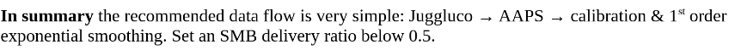
autoISF automatically detects whether values come through Jugglucoo, and adjusts parabola fit calculations to determine acceleration etc. –
When running on Libre3 / 1 minute, you get many more SMBs that each are, on average, much smaller. This has implications on some related settings (notably, the smb_range_extention, see section 2.1).

For more info, please refer to the multi-page section “Using 1 minute data in autoISF” in the autoISF 3.1.0 Quick Guide, https://github.com/ga-zelle/autoISF

It is currently too early to tell, but the 1 minute values applied to the parabolic bg curve fit could present an avenue to earlier/better acceleration detection than the 5-minute CGMs enable.
Actually, 1 minute between two bg readings may sometimes be too short for the algo to go through all calculations + your pump to execute the job at hand:

“My favourite theory for missed loops is due to slow pumps. With my original Combo the new V2 driver in AAPS used disconnect/connect between loops which took about 25 sec on average and sometimes much longer before dealing with the real task. With the out-of-date Ruffy driver things were better. So I switched to Dana-i with its much faster communication. But there, the SMB speed is so slow that bottom line the improvement is minor.” (ga-zelle, Discord FCL 6.12.2025)

Tests done prior to introducing the 1 minute Libre3 option (from autoISF 3.0.1 onwards) showed overall comparable but smoother insulin delivery.

Call for a case study 1.8 from a Libre3 user!.

Unfortunately, Libre 3 (1-minute) was not included in the 10 CGM systems comparison we quoted 3 pages above

1.5 Meal-related limitations?

Setting up a full closed loop is relatively easy for people whose diet does not consist mainly of components with rapid high effect on blood glucose (more see https://androidaps.readthedocs.io/en/latest/Usage/FullClosedLoop.html#meal-related-limitations )

Meals do not have to be low on carb (provided you use a fast insulin for your FCL)
Fat or protein rich diets, or slow digestion/gastroparesis, make things easier rather than harder for the full closed loop because late carbs nicely cover for inevitable “tails” of late action from SMBs needed before or around peak time.

Erratic consumption of smaller snacks with fast resorbing carbs can be a problem.
In autoISF you can reduce this problem to some extent via one or two keystrokes from your AAPS home screen. While certainly being a deviation from the FCL idea(l), this would be one of the exceptional situations where you better do a quick “nudging” step from your “FCL cockpit”. Details see in section 5.2.1 and case study 5.2

Really, there are no meal limitations.
The sketched more problematic options just force you to decide which extra “nudging” efforts and/or worsened %TIR (and/or “behavioral adjustments”, like less snacking) you are willing to accept.

1.6 Lifestyle-related limitations?

Providing a technically stable system

Full closed looping requires a 24/7 technically stable system, especially regarding
- reliable CGM signals
- Bluetooth stability with the pump (see case study 1.4 and 1.6)
- keeping your phone in sufficient proximity at all times
- avoiding (or at least early recognition of) occlusion (see case study 1.1 and 1.6).
This requires a habit (or, unlikely, permanent attention to details) like keeping all components well charged and in close proximity; making cannula (or pod) changes always early enough to lower the risk of occlusion; and having always potentially needed parts with you.
Depending on your system, your experience with it, but also on your acceptance and general lifestyle, these aspects may or may not limit you.

Preparing for exercise

To prepare for exercise (sports, heavy work), the normal protocol with a pump or hybrid closed loop is to take actions that reduce insulin on board prior to exercise
With your full closed loop, the algorithm is tuned to detect meals and to give you insulin to counter glucose rises automatically. Setting a high temp. target and lower %profile, effective already around meal start, could be a problem.
Unusual activity levels therefore likely require disciplined preparation (especially if you want to keep the need to snack during sports low)

In autoISF you can reduce this problem to some extent via two or three keystrokes on your AAPS home screen. While certainly being a deviation from the FCL idea(l), this would be one of the exceptional situations where you better “flick a lever” from your “FCL cockpit” to keep iob low (example see case study 6.2).

Extra hurdles to establish FCL for kids

To establish and maintain a FCL for kids brings about some extra challenges if:
- Lyumjev is not available or well tolerated
- Hourly basal rates are very low, providing a poor basis for big SMBs
- Diet is rich in sweet components. With the typical low blood volume of a small body, strong tendency towards very high bg spikes!
- Going through marked changes of insulin sensitivity or of circadian pattern makes it difficult to keep the FCL appropriately tuned.
This problem is about the same in FCL as it is also in Hybrid Closed Looping. However, now you might expect miracles from the FCL. This is not going to happen. You still must be pro-active by setting suitable temporary % profiles. (These serve as a basis, also for your autoISF FCL, which generally modulates the at-the-time-valid profile_ISF, for further enhanced (or reduced) loop aggressiveness).
- Discipline may be poor regarding keeping 24/7 Bluetooth connectivity
- Discipline may be poor regarding keeping infusion sites perfectly running.
- Between kid and supervising parent it must be guaranteed, especially in the initial weeks, that an eye is kept on whether the FCL is working about as expected.
More see section 7.

1.7 Time required for setting-up

Lastly, before enjoying a functioning full closed loop, you need to have a period of a some weeks with some free time and „free head“ for set-up –. Can you get, in the time you are willing to invest, to a result that you consider good-enough is really the question. Depending on your „habits“, and which – if any - compromises (like doing cannula/pod changes more often, never starting meals when bg sits high and is not predicted to rush down soon … ) are you willing to make (and everyday able to stick to), for the ease of not having to deal with assessing meals and bolusing for them?

1.7.1 Recommended structured, step-by-step approach (see also beginning of section 4)

Setting up your personal FCL using autoISF is a substantial project, for which you should follow the sequence as described in this e-book.

But there is no need to implement it fully in one step.
- There is nothing wrong to go in your well running Hybrid Closed Loop mostly, while switching to FCL only for dinners, for instance, or only for weekend lunches, as a start.
- Once you found feasible settings, you can expand to other meal times…
- …. and lastly towards figuring out your best strategies for challenges aside from meal management, as we shall discuss in sections 5. and 6.

There are alternatives to using autoISF for FCL, as well. See sections 7 and 13. for more info.

Notably FCL using AAPS Master and Automations (see in section 13.1).could be a much easier and more error-tolerant way of stepping into FCL. In a clinical study with 16 participants about 80% TIR was achieved without much tuning effort

Also, watch out for what a 2025 on-going FCL study with AAPS in Australia and NZ will show. See CLOSE IT trial protocol in: ).
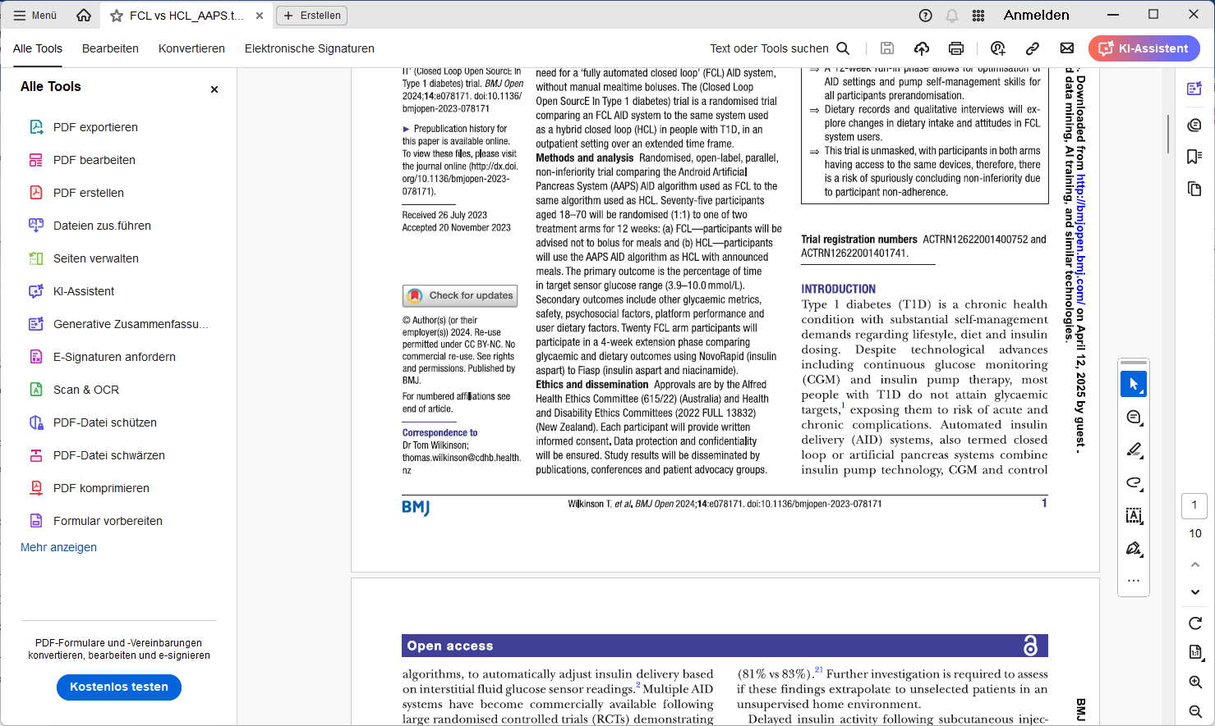

To close the circle to where we had started; A very time consuming pre-requisite might actually be to first sort out your Hybrid Closed Loop (section 1.1), so your profile parameters are set „right“, and your “old” data really can serve as a blueprint for what, now, you would like your loop to do in FCL mode
If you feel you better do your homework first there, I highly recommend some of the material in the neighboring HCL repo: https://github.com/bernie4375/HCL-Meal-Mgt.-ISF-and-IC-settings
1.7.2 “Trial and error” fast track alternative

Note that if you had used dynamic parameters or special Automations („loops inside the loop“) this might have balanced some principal errors, but leaves you now without a good starting point, as now you must get rid of these over-patches (see also warnings at start of section 4)..

Nevertheless, you will find FCL success stories also from loopers who continue(d) in that spirit, and just jump(ed) into using more powerful tools, in kind of a trial and error mode, frequently adding the latest add-on, or self-constructed patch (often in form of an Automation), to counter-balance encountered problems.

Resulting solutions may be good-enough.

However, they tend to be unstable and not well-understood. That is a poor basis for managing arising problems, and for temporarily adjusting to special situations.
Nevertheless, this is an alternative avenue for the impatient, less analytically, and more adventurous inclined.
Note though, that it is hard to consult (help) someone who, over time, constructed his/her own complicated maze of constructs.
Still, I welcome everyone’s creativity. “Not macht erfinderisch” (necessity is the mother of invention) we say in German: Something amazing of broader interest could emerge, and help push innovation for us all.

Be prepared to needing a fresh re-start, in case your trial-and-error got you completely lost. Depending on knowledge level and experience, this could happen on a “fast track” route.

1.7.3 Safety first

Regardless which route you choose, PLEASE always observe the safety settings/instructions coming with the DIY dev- variant of FCL software you select.

All FCL methods come with boosted SMBs. So a key safety measure every user going towards any FCL should have in place is to set an iob threshold (iobTH; size a bit below what you used as a bolus for bigger meals in HCL) above which no more SMBs can be given by your FCL.

- iobTH is an integrated feature of autoISF (see section 2.4).
- Other AAPS-based FCL methods may require to set up an Automation for a temporary iob threshold that blocks SMBs from being delivered, see e.g. here for AAPS FCL w/Automations; :https://androidaps.readthedocs.io/de/latest/Usage/FullClosedLoop.html#iob-threshold .
- In case there are other methods than autoISF for FCL also on the iAPS or Open iAPS platforms, you may have to rely on an adjusted iob_max border, or watch the iob development, and intervene with a SMB shut-off, or by opening the loop, when deemed necessary.

Also, make use of the easy-to-use feature of SMB shut-off at odd profile or temporary target. This can at any time easily be done manually, via the top right “TT” field in your AAPS screen (set, and time, an odd-numbered target; section 5.1.3), and can be of enormous help to temporarily safeguard you from aggressive loop actions (i.e. further growth of iob, no matter how close you already may be to the iobTH)-
This is the same concept that you already know from your HCL times, when you wanted to “tame your loop” so it does not “fight” your anti-Hypo Snack with a SMB (An elevated TT> 100 mg/dl was then used, to shut off SMBs in HCL for a while).
Lastly, make sure you “train”, for your set-up weeks, how/when to transition between FCL and your prior HCL mode (refer to section 5.2.3 and 5.1.1 ).

